**2D into 3D**

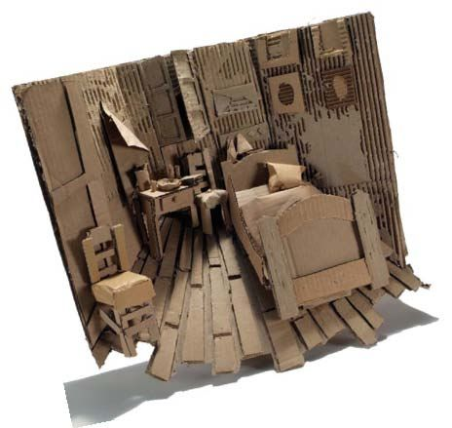**Reinterpreting Famous Artworks from History**

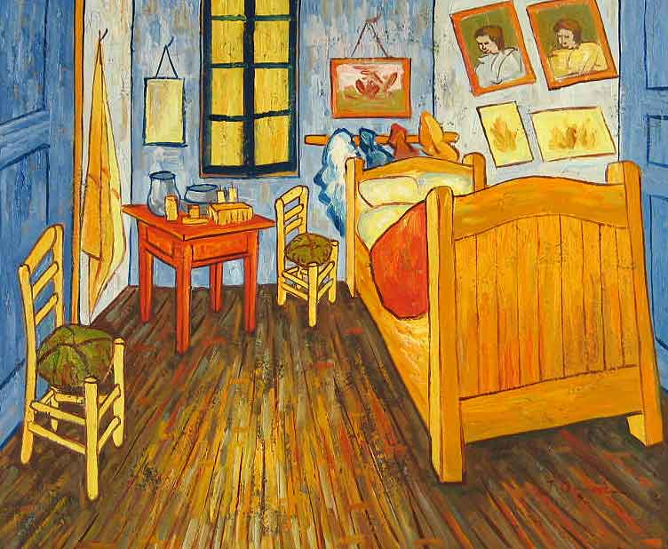

Select a well known and recognizable painting that you would be interested in recreating in 3D using only cardboard – no 2 students may select the same painting but are allowed to use the same artist.

**Vocabulary:**

Foreground:

Middle ground

Background:

Relief sculpture:

Bas-relief (low relief):

High relief:

Texture:

Depth:

Space:

**Research the painting:**

Title and Date of Painting:

Artist name:

Art movement the artist belongs to:

Briefly describe this art movement:

Write 1-2 paragraphs explaining any background or special meaning of the painting and/or artist:

**Planning the Design:**

1. Print a clear image of the painting you plan to reinterpret.
2. Look at the painting for areas that can become different layers. What parts would be flat against the base? What would stick out the farthest? How would you deal with the parts that fall in between?
   1. It can be helpful to number the layers; 1 being the lowest and building up from there
3. Do a sketch of the different layers of the image. The desired size should be no larger than 12”X14” and no smaller than 8 ½” X 11”
   1. The composition should include a foreground, middle ground and background – consider the scale of the different objects
   2. There should be at least 5 different layers to your sculpture to create a sense of depth and space
   3. Simplify complex shapes – they will be easier to cut
   4. Be sure to include some areas of texture – one way this can be done by ripping the top layer of paper away from the cardboard in areas to show the corrugated (wavy) portion underneath
4. Have your plan approved before you begin constructing